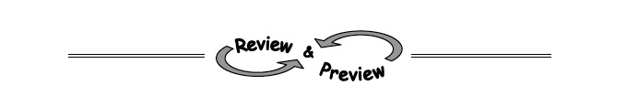
4-49. Camila is trying to find the equation of a line that passes through the points (−1, 16) and (5, 88). Does the equation y = 12x + 28 work? Justify your answer.

4-50. The graph below contains the lines for y = x + 2 and y = 2x − 1.
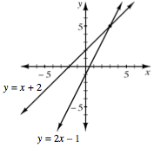
a. Using the graph, what is the solution to this system?

b. Solve the system algebraically to confirm your
answer to part (a).

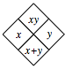4-52 Complete each of the Diamond Problems below. The pattern used in the Diamond Problems is shown at right.
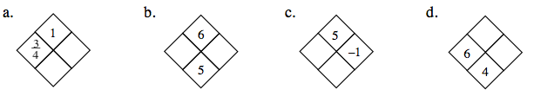

4-51. Hotdogs and corndogs were sold at last night's football game. Use the information below to write mathematical sentences to help you determine how many corndogs were sold.
  - The number of hotdogs sold was three fewer than twice the number of corndogs. Write a mathematical sentence that relates the number of hotdogs and corndogs. Let h represent the number of hotdogs and c represent the number of corndogs.

  - A hotdog costs $3 and a corndog costs $1.50. If $201 was collected, write a mathematical sentence to represent this information.

  - How many corndogs were sold? Show how you found your answer.

4-54. Solve the following equations for x, if possible. Check your solutions.

  - −(2 − 3x) + x = 9 – x b. $\frac{6}{x}= \frac{3}{4}$

