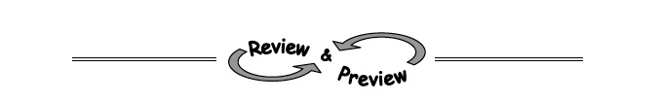

4-60. Find the point of intersection of each pair of lines, if one exists. If you use an equation mat, be sure to record your process on paper. Check each solution, if possible.
  - x = −2y −3
4y − x = 9
  - x + 5y = 8
−x + 2y = −1
  - 4x − 2y = 5
y = 2x + 10
4-61. Jai was solving the system of equations below when something strange happened.
y = −2x + 5
2y + 4x = 10
  - Solve the system. Explain to Jai what the solution should be.
  - Graph the two lines on the same set of axes. What happened?
  - Explain how the graph helps to explain your answer in part (a).
4-62. On Tuesday the cafeteria sold pizza slices and burritos. The number of pizza slices sold was 20 less than twice the number of burritos sold. Pizza sold for $2.50 a slice and burritos for $3.00 each. The cafeteria collected a total of $358 for selling these two items.
  - Write two equations with two variables to represent the information in this problem. Be sure to define your variables.
  - Solve the system from part (a). Then determine how many pizza slices were sold.
4-63. A local deli sells 6-inch sub sandwiches for $2.95. It has decided to sell a “family sub” that is 50 inches long. How much should it charge? Show all work.

4-64. Use generic rectangles to multiply each of the following expressions.
  - (x + 2)(x − 5)
  - (y + 2x)(y + 3x)
  - (3y − 8)(−x + y)
  - (x − 3y)(x + 3y)

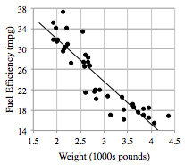
4-65. Consumer Reports collected the following data for the fuel efficiency of cars (miles per gallon) compared to weight (thousands of pounds).
  - e = 49 − 8.4w
  - w is the weight (1000s of pounds)
  - and e is the fuel efficiency (mpg).
  - Describe the association between fuel efficiency and weight.
  - Cheetah Motors has come out with a super lightweight sports utility vehicle (SUV) that weighs only 2800 pounds. What does the model predict the fuel efficiency will be?

