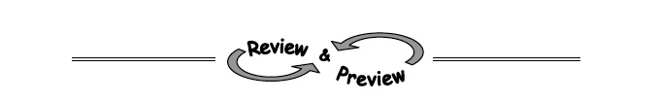
9-7. For each of the following equations, indicate whether its graph would be a line or a parabola.
  - 5x + 2y = 7
  - y = 3x²
  - y = 3
  - 4x² + 3x = 7 + y

9-8. Multiple Choice: Which equations below are equivalent to:
  - 3x − 7 + 5x = 10 − 3x
  - 3x − 14 + 5x = 2 − 3x + 8
  - 8x − 14 = 10 − 3x
  - 6x − 14 + 10x = 4 − 6x + 16

9-10. Examine the two equations below. Where do they intersect?
- y = 4x − 3
- y = 9x − 13

9-17. Solve the following quadratic equations by factoring and using the Zero Product Property. Be sure to check your solutions.
  - x² − 13x + 42 = 0

  - 0 = 3x² + 10x − 8

  - 2x² − 10x = 0

  - 4x² + 8x − 60 = 0

9-18. Use the Quadratic Formula to solve x² − 13x + 42 = 0. Did your solution match the solution from part (a) of problem 9-17?

