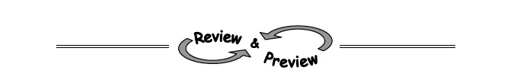
8-69. Use a similar process as you did in problems 8-65 and 8-67 to sketch the parabola for x² + x − 6 by using its intercepts.

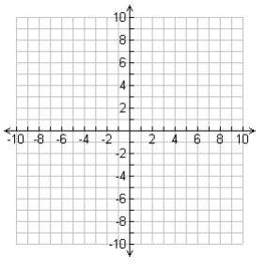

8-70. Compare the two equations below.
(x + 2)(x − 1) = 0 and (x + 2) + (x − 1) = 0
  - How are the equations different?

  - Solve both equations.

8-71. For each equation below, solve for x.
  - (x − 2)(x + 8) = 0 b. (3x − 9)(x − 1) = 0

8-74. Factor each quadratic below completely.
  - 2x² − 2x – 4

  - 4x² − 24x + 36

