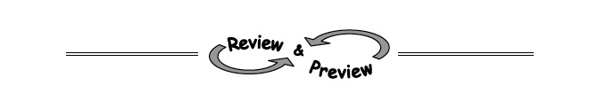
8-83. Use the Zero Product Property to find the roots of the polynomials below.
a. 3x² − 7x + 4 = 0

b. x² + 6x = 0

c. (x + 5)(−2x + 3) = 0

8-86. Sketch each parabola below with the given information.
  - A parabola with x-intercepts (2, 0) and (7, 0) and y-intercept (0, −8).
  - A parabola with exactly one x-intercept at (−1, 0) and y-intercept (0, 3).
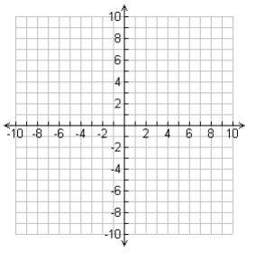

c. The parabola represented by the equation y = (x + 5)(x − 1).
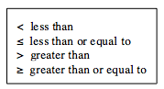
8-87. Review the meanings of the inequality symbols in the box at right. . Then decide if the statements below are true or false.

a. 5 < 7 b. −2 > 9 c. 0 < 0 d. −5 > −10 e. 16 < −16 f. 1 > 1

8-88. Calculate the value of each expression below using a scientific calculator.
- 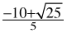 b. 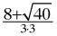 c. 