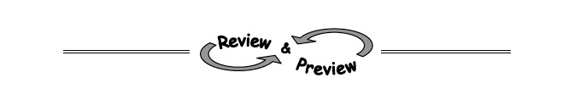

8-92. QUALITY CONTROL, Part TwoLots O’Dough, a wealthy customer, would like to order a variety of parabolas. However, he is feeling pressed for time and said that he will pay you lots of extra money if you complete his order for him. Of course you agreed! He sent you sketches of each parabola that he would like to receive. Determine a possible equation for each parabola so that you can pass this information on to the Manufacturing Department.
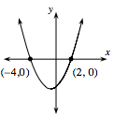
- 2.
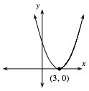
3. 4.
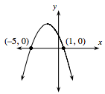
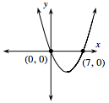

8-93. Find the slope and y-intercept of the line 6y − 3x = 24.

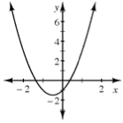
8-94. Examine the graph of y = 2x² + 2x − 1 at right.
a. Estimate the zeros y = 2x² + 2x − 1 from the graph.

b. What happens if you try to use the Zero Product Property to find the roots of 2x² + 2x − 1 = 0?

8-95. Solve the equations below for x. Check your solutions.
  - x² + 6x − 40 = 0

  - 2x² + 13x − 24 = 0

8-96. Calculate the expressions below. Then compare your answers from parts (a) and (b) to those in part (a) of problem 8-95, and parts (c) and (d) to part (b) in problem 8-95. What do you notice?
- 

 