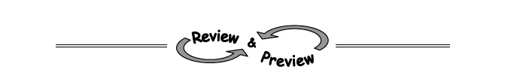

8-71. For each equation below, solve for x.
c. (x + 10)(2x − 5) = 0 d. (x − 7)² = 0

8-72. Examine the system of equations. 5x − 2y = 4
x = 0
- Before solving this system, Danielle noticed that the point of intersection is also the y-intercept of 5x− 2y = 4. Explain how she knows this.

- Find the point of intersection of the two rules above.

8-73. The (x-intercepts) of the graph of y = 2x² − 16x + 30 are (3, 0) and (5, 0).
  - What is the x-coordinate of the vertex? How do you know?

  - Use your answer to part (a) above to find the y-coordinate of the vertex. Then write the vertex as a point (x, y).

8-97. Use any method to solve the systems of equations below.
  - 2x − 3y = 5
4x + y = 3

  - m = −3 + 2n
4m + 6n = −5

8-107. Use factoring and the Zero Product Property to solve each equation.
- (x − 4)(2x + 1) = 0

- x² + 5x + 6 = 0

- x(2x − 5) = 0

- x² + 4x = 0

