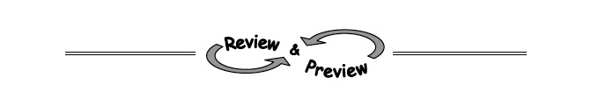
9-17. Solve the following quadratic equations by factoring and using the Zero Product Property. Be sure to check your solutions.
c. 2x² − 10x = 0 d. 4x² + 8x − 60 = 0

9-19. Does a quadratic equation always have two solutions? That is, does a parabola always intersect the x-axis twice?
  - If possible, draw an example of a parabola that only intersects the x-axis once.

  - What does it mean if the quadratic equation has no solution? Draw a possible parabola that would cause this to happen.

9-20. Find the equation of the line through the point (−2, 8) with slope .

9-22. The increased demand for vegetarian meals has caused an increase in the price of tofu. If the current cost of $2.99 per pound is increasing 6% per year, what will it cost in 5 years?

9-23. Decide if the statements below are true or false. If necessary, review the descriptions for the inequality symbols <, <, >, and > in the Lesson 9.2.1 Math Notes box.
- 11 < −13

- 5 (2) > 10

- 13 > −3(2 − 6)

- 4 < 4

- 9 > −9

- −2 > −2

- −16 < −15

- 0 > 6

