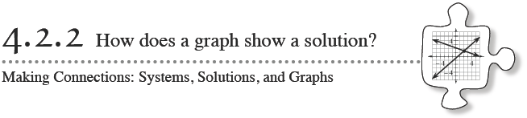
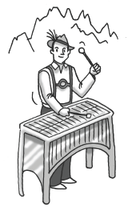
In this chapter you have practiced writing mathematical sentences to represent situations. Often, these sentences give you a system of equations, which you can solve using substitution. Today you will also represent these situations on a graph and will examine more closely the solution to a two-variable equation.

4-42. THE HILLS ARE ALIVE
The Alpine Music Club is going on its annual music trip. The members of the club are yodelers, and they like to play the xylophone. This year they are taking their xylophones on a gondola to give a performance at the top of Mount Monch.
The gondola conductor charges $2 for each yodeler and $1 for each xylophone. It costs $40 for the entire club, including the xylophones, to ride the gondola. Two yodelers can share a xylophone, so the number of yodelers on the gondola is twice the number of xylophones.
How many yodelers and how many xylophones are on the gondola?
How can the given information be represented with equations?
What is a solution to a two-variable equation?
How can this problem be represented on a graph?
How does the solution appear on the graph?
Your Task: Determine how many xylophones and yodelers are on the Gondola
  - Represent this problem with a system of equations. Solve the system and explain how its solution relates to the yodelers on the music trip.
  - Represent this problem with a graph. Identify how the solution to this problem appears on the graph.

4-46. Consider the system of equations:
2x + 2y = 18
y = x − 3
- Use substitution to solve this system.

b. With your team, decide how to fill in the rest of the table for the equation
2x + 2y = 18
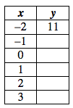

c. Use your table to make an accurate graph of the equation 2x + 2y = 18.

d. Now graph y = x − 3 on the same set of axes. Find the point of intersection.

e. Does the point of intersection you found in part (a) agree with what you see on your graph?
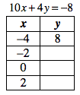
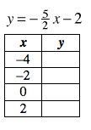4-47. The equation of two lines are given below. A table of solutions for the first equation has been started below the equation.

a. Without actually solving the system of equations, predict what the solution to this system will be. Explain.

b. Graph both equations.

c. Solve the system algebraically. Was your prediction in part (a) correct?

4-48.
What is a system of equations?
What is a solution to a system of equations?
Answer the above questions in complete sentences. Finally, make a list of all of the ways to represent solutions to a system of equations.

