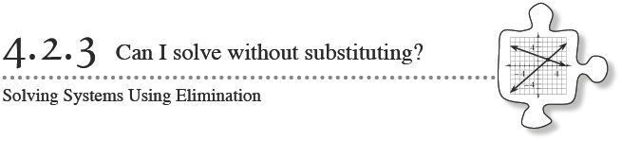

4-55. As a class use the elimination method to find the intersection point of these two equations:
3y + 2x = − 2
−3y + 5x = 16

- Why do you think the elimination method is a good name for this process?

4-57. Pat was in a fishing competition at Lake Pisces. He caught some bass and some trout. Each bass weighed 3 pounds, and each trout weighed 1 pound. Pat caught a total of 30 pounds of fish. He got 5 points in the competition for each bass, but since trout are endangered in Lake Pisces, he lost 1 point for each trout. Pat scored a total of 42 points.
- Write a system of equations representing the information in this problem.

- Is this system a good candidate for the Elimination Method? Why or why not?

- Solve this system to find out how many bass and trout Pat caught. Be sure to record your work and check your answer by substituting your solution into the original equations.

4-58. ANNIE NEEDS YOUR HELP
Annie was going to use the elimination method. She was ready to add the same value to both sides of the equation to eliminate the x-terms when she noticed a problem: Both x-terms are positive!
2x + 7y = 13
2x + 3y = 5

With your team, figure out something you could do that would allow you to add the value of the second equation to the first equation and eliminate the x-terms. Once you have figured out a method, solve the system and check your solution. Be ready to share your method with the class.

4-59. Find the point of intersection of each pair of lines below. Show your steps algebraically. Check each solution when you are finished.
- 2y − x = 5
−3y + x = −9

- 2x − 4y = 14
4y − x = −3

- 3x + 4y = 1
2x + 4y = 2

