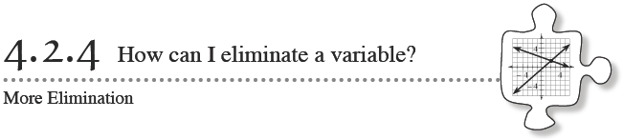
In Lesson 4.2.3, you learned how to use the Elimination Method to solve systems of equations. In this method, you combined two equations in a way that made one variable disappear. This method is particularly useful for solving systems of equations where neither equation is in y = mx + b form.
4-66. Which system of equations below would be easiest to solve using the Elimination Method? Once you have explained your decision, use the Elimination Method to solve this system of equations. (You do not need to solve the other system!) Record your steps and check your solution.
a. 5x − 4y = 37 b. 4 − 2x = y
−8x + 4y = −52 3y + x = 11

4-67. Rachel is trying to solve this system:
2x + y = 10
3x − 2y = 1

  - Combine these equations. What happened?

  - Is 2x + y = 10 the same line as 4x + 2y = 20? That is, do they have the same solutions? Are their graphs the same? Justify your conclusion! Be ready to share your reasoning with the class.

  - Since you can rewrite 2x + y = 10 as 4x + 2y = 20, perhaps this equivalent form of the original equation can help solve this system. Combine 4x + 2y = 20 and 3x − 2y = 1. Is a variable eliminated? If so, solve the system for x and y. If not, brainstorm another way to eliminate a variable. Be sure to check your solution.

4-68a. Is this system a good candidate for the Elimination Method? Why or why not?

5m + 2n = −10
3m + 2n = −2
What is the best way to get one equation with one variable? Carry out your plan and solve the system for both variables.

Is your solution correct? Verify by substituting your solution into both original equations.

4-68b. Is this system a good candidate for the Elimination Method? Why or why not?

6a − b = 3
b + 4a = 17
What is the best way to get one equation with one variable? Carry out your plan and solve the system for both variables.

Is your solution correct? Verify by substituting your solution into both original equations.

4-68c. Is this system a good candidate for the Elimination Method? Why or why not?
7x + 4y = 17
3x − 2y = −15

What is the best way to get one equation with one variable? Carry out your plan and solve the system for both variables.

Is your solution correct? Verify by substituting your solution into both original equations.

4-69. Tracy's team was given the following system by their teacher.
10x + 4y = −8
5x + 2y = 10

  - Combine these equations and solve. What happened?

  - Are these two equations the same line? How can you tell?

  - How can you explain the solution you got in part (a)?

4-70. A NEW CHALLENGE
Carefully examine this system:
4x + 3y = 10
9x − 4y = 1
With your team, propose a way to combine these equations so that you eventually have one equation with one variable. Be prepared to share your proposal with the class.

