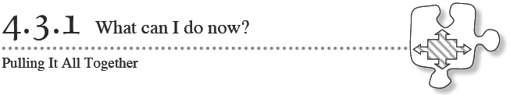As you solve the problems below, remember to make connections between all of the different topics you have studied in Chapters 1 through 4. If you get stuck, think of what the problem reminds you of. Decide if there is a different way to approach the problem.
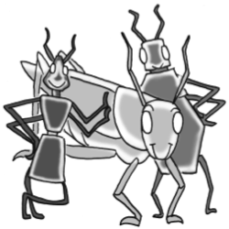
1. Brianna has been collecting insects and measuring the lengths of their legs and antennae. Below is the data she has collected so far.
 | Ant | Beetle | Grasshopper
Length of Antenna (x) | 2 mm | 6 mm | 20 mm
Length of Leg (y) | 4 mm | 10 mm | 31 mm

  - Graph the data Brianna has collected. Put the antenna length on the x-axis and leg length on they-axis.

  - Brianna thinks that she has found an algebraic rule relating antenna length to leg length: $y= \frac{3}{2}$x + 1.
If x represents the length of the antenna and y represents the leg length. Is Brianna’s rule correct. If yes, explain how you know this. Otherwise, find your own algebraic rule for relating antenna length to leg length.

  - If a ladybug has an antenna 1 mm long, how long does Brianna’s rule say its legs will be? Use both the rule and the graph to justify your answer.

2. Barry is helping his friend understand how to solve systems of equations. He wants to give her a problem to practice. He wants to give her a problem that has two lines that intersect at the point (−3, 7). Help him by writing a system of equations that will have (−3, 7) as a solution and demonstrate how to solve it.

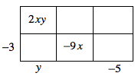
3. Examine the generic rectangle at right. Determine the missing attributes and then write the area as a product and as a sum.

4. Solve each equation and state how many solutions it has.
  - 4x −1 + 5 = 4x + 3 b. 6t − 3 = 3t + 6

  - 6(2m − 3) − 3m = 2m − 18 + m c. 10 + 3y − 2 = 4y − y + 8

5. Find the point of intersection of each pair of lines, if one exists. If you use an equation mat, be sure to record your process on paper. Check each solution, if possible
  - x = −2y −3
4y − x = 9

  - x + 5y = 8
−x + 2y = −1

  - 4x − 2y = 5
y = 2x + 10

6. Write an equation or system of equations and solve the problem below.
The French club sold rose bouquets and chocolate hearts for Valentine’s Day. The roses sold for $5 and the hearts sold for $3. The number of bouquets sold was 15 more than the number of hearts sold. If the club collected a total of $339, how many of each gift was sold?

