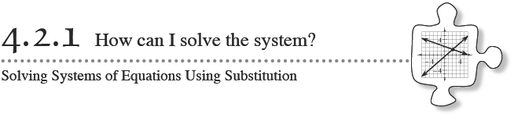
In Lesson 4.1.2, you developed Equal Values Method of solving a system of equations. You set both of the equations equal to the same variable. Today you will develop a more efficient method of solving systems that are too messy to solve by setting the equations equal to each other.

WARM UP . Review what you learned in Lesson 4.1.2 as you solve the system of equations below. Use the equal values method to solve the systems and check your solution.
a. 6x + 3y = 9 b. y = + 5
y = 7x – 6 y = 2x − 9

4-31. Set up the following system of equations to solve using the equal values method
y = −x − 7
5y + 3x = −13

4-32. AVOIDING THE MESS
A new method, called the Substitution Method, can help you solve the system in problem 4-31 without using fractions. This method is outlined below.
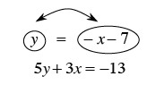

  - If y = −x − 7, then does −x − 7 = y? That is, can you switch the y and the −x − 7? Why or why not?

  - Since you know that y = −x − 7, can you replace the y in the second equation with −x − 7 from the top equation? Why or why not?

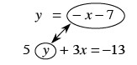

  - Once you replace the y in the second equation with −x − 7, you have an equation with only one variable, as shown below. This is called substitution because you are substituting for (replacing) y with an expression that it equals. Solve this new equation for x and then use that result to find y in either of the original equations.
5(−x − 7) + 3x = −13

4-33. Use the Substitution Method to solve the systems of equations below.
a. y = 3x b. x − 4 = y
2y − 5x = 4 −5y + 8x = 29

c. 2x + 2y = 18 d. c = −b − 11
x = 3 – y 3c + 6 = 6b

4-34. When Mei solved the system of equations below, she got the solution x = 4, y = 2. Without solving the system yourself, can you tell her whether this solution is correct? How do you know?
4x + 3y = 22
x − 2y = 0

