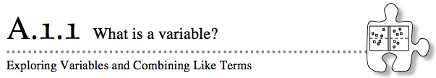
In Algebra and in future mathematics courses, you will continue to work with unknown quantities that can be represented using variables. Today you will be introduced to tools called “algebra tiles” that will help you and your team members answer some important questions about algebra, such as “What is a variable?” and “How can we use it?”
A-1. Your teacher will give you and your team a set of algebra tiles to use during this algebra course. As you explore the tiles, discuss the following questions with your team. Be prepared to share your responses with the class
- How many different shapes can you find? What are the names of all of the different shapes?
  - How are the shapes different? How are they the same?
  - How are the different kinds of shapes related? Which fit together and which do not?
A-2. Draw a picture of each size of tile on your paper. Then complete the activities below.

  - The algebra tiles will be referred to by their areas. Since the smallest square has sides 1 unit long, its area is 1 square unit. The name for this tile, then, is “one.” It can also be called a “unit tile.” Can you use the unit tile to find the lengths of the sides of the other algebra tiles? Why or why not?
  - Name the other tiles using their areas. Be sure to use what you know about the area of a rectangle and the area of a square.
A-3. JUMBLED PILES
Your teacher will show you a jumbled pile of algebra tiles and will challenge you to name all of them. What is the best description for the collection of tiles? Is your description the best possible?

SIMPLIFY EXPRESSIONS BY COMBINING LIKE TERMS
A-4. Build each collection of tiles represented below. Then name the collection using a simpler algebraic expression, if possible. If it is not possible to simplify the expression, explain why not.
- 3x + 5 + x² + y + 3x² + 2 b. 2x² + 1 + xy + x² + 2xy + 5

c. 2 + x² + 3x + y² + 4y + xy d. 3y + 2 + 2xy + 4x + y² + 4y + 1

A-13. Use tiles to build each of the shapes, a-d, below. Write an expression that represents the perimeter and simplify the perimeter expression as much as possible.
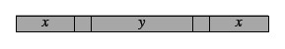

Perimeter:____________________________________________

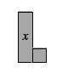
b.
Perimeter:____________________________________________

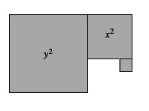
c.

Perimeter:_________________________________
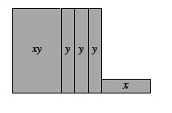
d.

Perimeter:_______________________________

A-14. Calculate the perimeter of the shapes in problem 2-13 if the length of each x-tile is 3 units and the length of each y-tile is 8 units. Show all work.
a. | b.
c. | d.

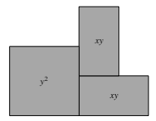
A-15. EXTENSION
If the perimeter of the shape at right is 32 units, what are possible values for x and y? Is there more than one possible solution for each variable? If so, find another solution. If not, explain how you know there is only one solution.

LEARNING LOG: Create your own shape using three different-shaped algebra tiles. Draw the shape and show how to write a simplified expression for its perimeter. Title this entry “Finding Perimeter and Combining Like Terms” and include today’s date.

