Geometry Midterm Exam Review

Use this diagram to answer questions 1 - 8. AB ∥ CD.
E
A 1 2 B
3 4

C 5 6 D
7 8
F

1. If m∠1 = 2x+5 and m∠7 = 3x-10, solve for x.

2. ∠4 and ∠5 are what type of angles? What is their relationship?

3. If m∠3 = 4x and m∠5 = 3x+75, what is the measure of angle 5?

4. What type of angles are ∠2 and ∠6? What is their relationship?

5. If m∠8 = 135°, find all of the other angle measures.

6. If the intersection of line AB and line EF is point O, write another name for angle 2.

7. What type of angles are ∠5 and ∠8? If m∠5 = 2x + 15 and m∠8 = 3x – 5, find the m∠8.

8. If you were not told that lines AB and CD were parallel, tell what information you would need to know to prove them parallel.

Use the following diagram to answer questions 9-12.

B C D

A E
F

9. List all of the pairs of supplementary angles.

10. If m∠CFD = 29°, find the m∠DFE.

11. If m∠BFA = 9x - 2 and m∠BFE = x – 18, find the measure of both angles.

12. If m∠CFD = 20° and m∠DFE = 4x – 10, solve for x.

Use the following diagram to answer questions 13 – 16.
A
a
B
F
C
D

13. If the m$∠$ABF is 65˚, find the m$∠$ACD.

14. Classify the triangle ABC by its sides and angles.

15. What is the segment AF called in this triangle?

16. If the m$∠$B is x – 2 and the m$∠$BCA = 2x – 16, find the m$∠$A and m$∠$ACD.

17. For each pair of triangles below, decide if the triangles are similar. If so, make a flowchart and find the value of x. If not, or there is not enough information, describe why not or what information is missing.
a. b.
27°
54°
27°
99°
I
S
N
J
O
B
6
21
x
3.37
7.33
12
10
3
2.5

10
A
W
T
U
S

18. What are the possible lengths for side in the triangle below? Show how you know.
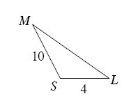
19. In the following triangle that is not drawn to scale, name the shortest and the longest sides.

A

15°

70° 95°
B C

20. For each figure, draw the transformation described. Be sure to label your results!

a. Reflect across line l. b. Rotate MATH counter –clockwise ()about the origin.
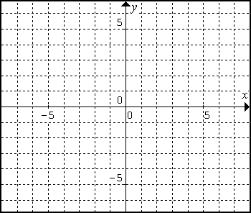
M
H
T
A
A
B
C
l

21. Find the area of the trapezoid.
13cm
25cm
8cm
10cm

22. Dilate the shape below using a zoom factor of 3 from the origin.
O

23. Solve for x. 3x

2x + 10 x + 2

24. For each triangle below, find the missing angle or side length.

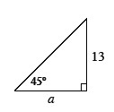
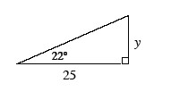
a. b.

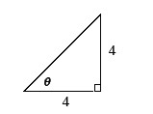
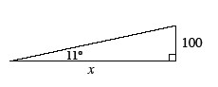
c. d.

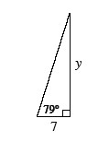
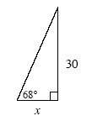
e. f.

25. What is the distance between the points (−2, −5) and (6, 3)?

26. Solve for x.

a. 55° b.
4 6
14 6 55°

80°
45° 3
X 8 x

27. True of False? If false, state why.
_____ If a shape is magnified by a factor of k, the ratio of perimeters between the new figure and the original figure is k.
_____ If two shapes are congruent, then their zoom factor is zero
.
_____ All equilateral triangles are similar.

_____ All rectangles are similar.
_____ If a shape is magnified by a factor of k, the ratio of areas between the new figure and the original figure is k.

28. Which of the following are the side lengths of a right triangle?

a. 16, 30, 34 b. 6, 7, 8 c. 9, 12, 13 d. 5, 10, 12

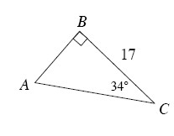
29. Find the area of the triangle at right. Show all work.

