THE PYTHAGOREAN SPIRAL PROJECT
= 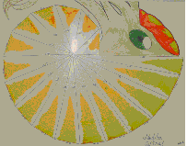 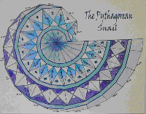
You will create a poster of the Pythagorean spiral. The result needs to be colored and may be creatively decorated. You will need to turn in your poster and a separate piece of paper with all calculations.

Materials: + poster board + ruler + straightedge or large index card + pencil, colored pencils or markers

Step 1: Place the poster board in landscape orientation. Measure from the top left hand corner 27.5 cm right and 20.5 cm down. This will be the starting point for your diagram. It will assure that your diagram stays on the page.

Step 2: Using your ruler create a segment that is 10 cm across starting from the starting point and heading towards the center of the poster. Make this segment perpendicular to the side of the poster. Use your straightedge and ruler to construct a congruent segment that is perpendicular to the original. Connect the endpoints of the two segments to create a right isosceles triangle. Lightlylabel this triangle as (1).
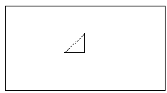

Step 3: On a separate piece of paper, use the Pythagorean Theorem to calculate the length of the hypotenuse for triangle (1). Show all work and write your answer to the nearest tenth.

Step 4: Using the hypotenuse of the first triangle, create another right triangle on top of the previous hypotenuse. The old hypotenuse will be the new base and construct a perpendicular segment to this, with a length of 10. Then connect the two segments to form a new hypotenuse. Lightly, label this triangle as (2).

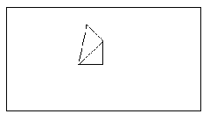
Step 5: On your separate piece of paper, show the calculations to find the length of the new hypotenuse.

Step 6: Continue to repeat this process of connecting, constructing, and labeling new triangles with a side length of 10, using the previous hypotenuse as the other side. Continue to show your calculations on your separate piece of paper. Construct triangles until you have formed a full spiral.

Step 7: Detail your Pythagorean Spiral with a design. Use color and a pattern to make a creative picture.

TO TURN IN:
Your poster with light pencil lines shown for constructions and color used to decorate the pattern. Your work for each hypotenuse length on a separate sheet of paper.

Grading Rubric for Pythagorean Spiral Project
Number of Points | Use straightedge Constructions | Calculations for each hypotenuse | Poster Result | Creativity
4 | Evidence of each straightedge construction shown | All work is shown using the Pythagorean Theorem and each answer is simplified | The result shows 17 right triangles that rotate around to the right and the last triangle overlaps the original | The poster is creatively colored and decorated
3 | Evidence of most straightedge constructions shown | All work is shown using the Pythagorean Theorem but some answers are not properly simplified | The result shows an error in construction resulting in one fewer or one more triangle | The poster is colored but the results are not neat.
2 | Partial or incorrect constructions shown | All work is shown but with errors in calculation and/or simplification | The result goes the wrong direction and/or is off by more than one triangle | The poster is partially colored or incomplete.
1 | Construction markings are not visible | Only partial work is shown and/or no evidence of the Pythagorean Theorem | The result does not appear to have followed the proper requirements | The poster is not colored or decorated
A: 15 - 16 B+: 13 – 14 B: 11 – 12 C: 9 – 10 C: 7 – 8 D+: 6 D: 5 F: 0 – 4

