**Round 1**

1. Which graphs below have a domain of all numbers?
2. Which have a range of all numbers?
3. Which are functions?

a b c

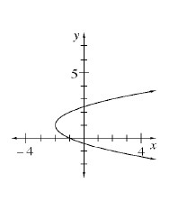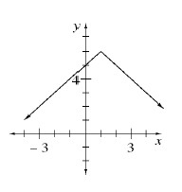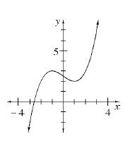

**Round 2**

Use what you know about *y* = *mx* + *b* to graph each of the following equations quickly on the same set of axes.

*y* = 3*x* - 5

*y* = −2*x* + 4

*y* = 1.5*x*

**Round 3**

What value(s) of x will make each equation below true?

a. 5 = 7 - |*x*| b. 3*x* + 1 = 22 c. 5 = $\sqrt{x+14}$

**Round 4**

According to the following function machines, find the missing input or output.

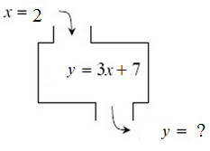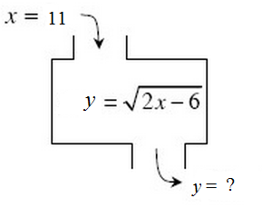

**Round 5**

Copy and complete the table below. Then write the corresponding equation.

|  |  |  |  |  |  |  |
| --- | --- | --- | --- | --- | --- | --- |
| IN (*x*) | 2 | 4 | 6 | 7 |  | 10 |
| OUT (*y*) | −7 | −17 |  |  | −37 |  |

**Round 6**

Find the missing dimensions (length and width) or area of each part and write the area of the rectangle as a product and a sum.

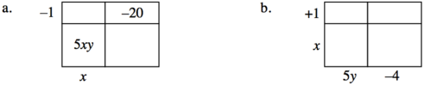

**Round 7**

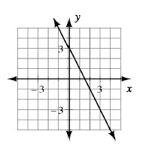Below are three different representations of a tile patterns. For each one, determine how the pattern is growing and the number of tiles in Figure 0.  In other words, find m and b, then write the rule.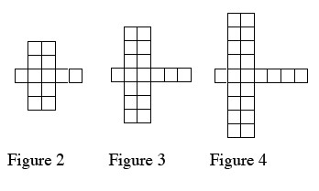

|  |  |  |  |  |  |  |  |
| --- | --- | --- | --- | --- | --- | --- | --- |
| ***x*** | −3 | −2 | −1 | 0 | 1 | 2 | 3 |
| ***y*** | 18 | 13 | 8 | 3 | −2 | −7 | −12 |

**Round 8**

Each of the following expressions represents the area of a rectangle and is written as either a product or a sum. Decide whether each is a product or sum then rewrite it in the other form.

a.        4(x + 5)          b.        10x + 20

c.        (2*x* + 1)(3*x* – 2)       d.        –3(2y + 5)

**Round 9**

Compute the following without using a calculator:

a. (5)2 + 3 b. (-1) + c. 3 + |2 – 5|

**Round 10**

Examine this tile pattern and answer the questions below.

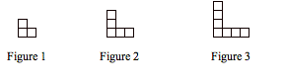

a. Write a rule that describes this pattern.

b. Which figure number has 41 squares? Show or explain how you figured it out.

**Round 11**

Write the area of the rectangle below as a product and as a sum.

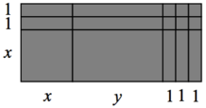

**Round 12**

Simplify the expressions

1. *k*−5 b. *m*0 c. *x*−2 · *x*5 d.

e. (3*x*3)2 f. 3*a*2*b* 4*a*3*b*6 g.(x5)-1 h.

**Round 13**

Solve the equations below for x and check your solutions.

a. - (3 – 2*x*) = −*x* + 6 b. 5 − 3*x*= *x* + 15 c. −2(*x* + 6) = 14

**Round 14**

For each of the following generic rectangles, find the dimensions (length and width) and write the area as the product of the dimensions and as a sum.

1. 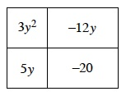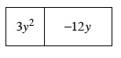 b.

**Round 15**

If $f\left(x\right)=x^{2}+ 2$, complete the following.

|  |  |  |  |  |
| --- | --- | --- | --- | --- |
| a. | b. | c. | d. | e. |