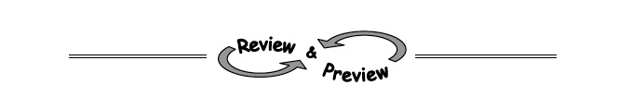
CL 3-113. Two brothers, Martin and Horace are in their back yard. Horace is taking down a brick wall on one side of the yard while Martin is building a brick wall on the other side. Martin starts with zero bricks in his wall, but can lay 2 bricks every minute. Meanwhile, Horace’s wall is made up of 200 bricks and he takes down 3 bricks each minute.
Write an equation in y = mx + b form for each brother.

CL 3-114. Rewrite each of these products as a sum.
  - 6x(2x + y − 5)
  - (2x² − 11)(x² + 4)
  - (7x)(2xy)
  - (x − 2)(3 + y)
CL 3-115. Find the missing areas and dimensions for each generic rectangle below. Then write each area as a sum and as a product.
  - 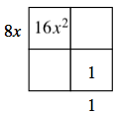 b. 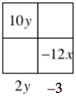

CL 3-118. Simplify each expression.
  - (x³)² ^{b.} 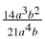 ^{c.} 2m³· 3m

  - e. (3x²)⁰ c. 5xy³· 3x²y⁵ d. x⁻²

CL 3-119. Determine the equation of each line from the given representation.
  - 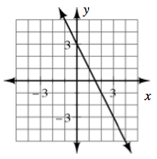
  - A line with a slope −and passes through the point (−3, 4).

x | −4 | −3 | −2 | −1
y | −11 | −9 | −7 | −5

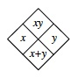
3-85. Complete each of the Diamond Problems below. The pattern used in the Diamond Problems is shown at right.
