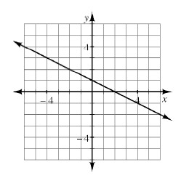
STUDY GUIDE Unit 2
CL 2-101. For the line graphed at right:
  - Find the slope.
  - Find the y-intercept.
  - Write the equation.

CL 2-102. Find m and b in the following equations. What do m and b represent?
- y = 1 + 2x b. y = − 4

CL 2-104. Frosty starts with $85 in the bank and saves $15 every 2 months. Write an equation for the balance of Frosty’s bank account.

CL 2-105. Find the slope for each linear relation described in the tables below.

x | −2 | −1 | 0 | 1 | 2
y | 19 | 14 | 9 | 4 | −1

x | 2 | 3 | 4 | 5 | 6
y | 22 | 31 | 40 | 49 | 58

CL 2-106. Write a rule for the given tile pattern. Hint: Make a table first.
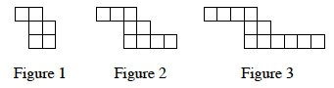

How many tiles will be in figure 58?

CL 2-107. Solve for w: 6w − 5 + 8w − 2w − 3 = 9w – 24

CL2-108. Complete the table below for the rule y = x² − 6x + 5. Then graph the rule.
x | −1 | 0 | 1 | 2 | 3 | 4 | 5 | 6 | 7
y |  | 5 |  |  |  | -3
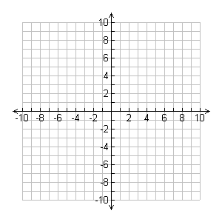

- Is the relation a function?

- State the domain and range.

CL 2-109. Find the slope of the line that passes through the points (−5, 7) and (10, 1).

