Dilations
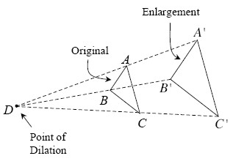
The transformations you studied in Chapter 1 (translations, rotations, and reflections) are called rigid transformations because they all maintain the size and shape of the original figure.

However, a dilation is a transformation that maintains the shape of a figure but multiplies its dimensions by a chosen factor. In a dilation, a shape is stretched proportionally from a particular point, called the point of dilation or stretch point. For example, in the diagram at right, ΔABC is dilated to form ΔA′B′C.Notice that while a dilation changes the size and location of the original figure, it does not rotate or reflect the original.
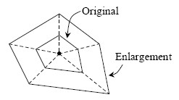
Note that if the point of dilation is located inside a shape, the enlargement encloses the original, as shown below right.

3-5. Plot the rectangle ABCD formed with the points A(−1, −2), B(3, −2), C(3, 1), and D(−1, 1) onto graph paper. Use the method used in problem 3-2 to enlarge it from the origin by a factor of 3. Label this new rectangle A′B′C′D′.
- What are the dimensions of the enlarged rectangle, A′B′C′D′?
- Find the area and the perimeter of A′B′C′D′.
- Find AC (the length of ).

3-8. On graph paper, graph line if M(−1, 1) and U(4, 5).
- Find the slope of .
- Find MU (the distance from M to U).
- Are there any similarities to the calculations used in parts (a) and (b)? Any differences?

3-17. Enlarge the shape below on graph paper using a zoom factor of 4.
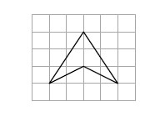

3-20. Examine the relationships in the diagram below. Then solve for x and y, if possible.
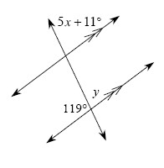

Advanced Extension:
3-19. The temperature in San Antonio, Texas is currently 77°F and is increasing by 3° per hour. The current temperature in Bombay, India is 92°F and the temperature is dropping by 2° per hour. When will it be as hot in San Antonio as it is in Bombay? What will the temperature be?

