Unit 9 Day 2 Homework 9-33, 9-34, 9-40, 9-41, 9-49, 9-50

9-33. Cindy’s cylindrical paint bucket has a diameter of 12 inches and a height of 14.5 inches. If 1 gallon ≅ 231 in³, how many gallons does her paint bucket hold?
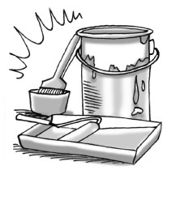

9-34. Multiple Choice: Which ratio below is the best approximation of the ratio between the circumference of a circle and its diameter?
a. 2 | b. 3 | c. 4 | d. 6

9-40. Draw a cylinder on your paper. Assume the radius of the cylinder is 6 inches and the height is 9 inches.
  - What is the surface area of the cylinder? What is the volume?

  - If the cylinder is enlarged with a linear scale factor of 3, what is the volume of the enlarged cylinder? How do you know?

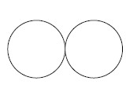
9-41. While Katarina was practicing her figure skating, she wondered how far she had traveled. She was skating a “figure 8,” which means she starts between two circles and then travels on the boundary of each circle, completing the shape of an “8.” If both circles have a radius of 5 feet, how far does she travel when skating one “figure 8”?

9-49. Elliot has a modern fish tank that is in the shape of an oblique prism, shown at right. If the slant of the prism makes a 60° angle, find the volume of water the tank can hold. Assume all measurements are in inches.
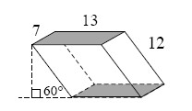

9-50. Decide if the following statements are true or false. If they are true, explain how you know. If they are false, provide a counterexample.
  - If a quadrilateral has two sides that are parallel and two sides that are congruent, then the quadrilateral must be a parallelogram.

  - If the interior angles of a polygon add up to 360°, then the polygon must be a quadrilateral.

  - If a quadrilateral has 3 right angles, then the quadrilateral must be a rectangle.

  - If the diagonals of a quadrilateral bisect each other, then the quadrilateral must be a rhombus.

